HISTORY OF THE BREED

In 1623, two heifers and a bull from north Devonshire, England, were received by a member of the Plimoth Colony. They were the first importation of cattle from Britain, although the Spanish had introduced cattle in the south.
Their immediate value was as draft animals. Cattle from Devonshire had long been recognized in England for their speed, intelligence, strength, willingness to work, and ability to prosper on coarse forage, in a wide range of climates.
In later years, other cattle were imported and contributed to the American Devon, which developed as the ideal multipurpose breed. None could surpass it for draft work; the milk was good for cream and cheese making, and the carcass developed fine beef on poor forage.
The 1868 American Devon Herd Book, Vol. 2, was published in Springfield, Massachusetts. This herd book contained the perfect description of Devon Cattle.

"The late experience of the breeders of Devons only confirms their former opinion of the excellent qualities of the breed, for the three grand objects for which neat stock are kept, namely, milk, work, or beef, and their adaptation to many sections of our country, in preference to any other breed; also that they will produce as much milk, work, or beef, from the food consumed, or on a given quantity of land, as any other breed...The only objection ever presented to the breed, is "they are small;" but we can keep more of them, and that on shorter pastures and coarser food."

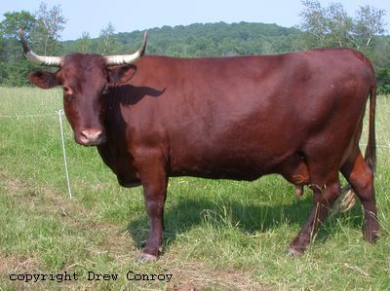

In more recent times, the importance of cattle for draft animals has all but disappeared, and the Devon has been replaced by high producing dairy breeds like the Holstein and Jersey, with whom it could not compete for quantity.
In 1952, the American Devon Cattle Club decided that the breed had to move into a specialist beef market in order to survive.
At that time, a small group of breeders decided to form a separate association for dairy cattle and maintain triple-purpose stock. That association slowly dwindled, but thanks to their efforts, many of their animals can be traced into the new registry which was re-formed in 1978. This registry represents a gene pool of genuine triple-purpose cattle able to survive and be productive under minimal management conditions in a harsh environment.
BREED DESCRIPTION

The Milking Devon is a medium sized triple-purpose breed adapted to survive on a low-quality, high forage diet under severe climatic conditions. They are healthy, long lived, and thrive on good care and management.
The breed is red in color, varying in shade from a deep rich red to light red or chestnut color. They may show white on the tail switch, udder or scrotum. They have medium sized curving horns that are light colored with dark tips.
The selection for meat or milk in this breed has never been the top priority.
The Devon cow is especially elegant with her compact rounded form, and when treated with kindness, possesses a docile temperament. They have very few calving difficulties and adequate milk production to raise a calf and for use on the small farm.
The Devon bull is noted for his ease of handling and even temperament, when treated kindly.

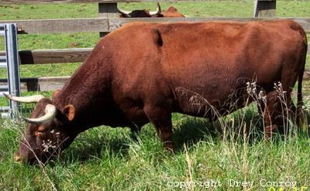
Devons were highly valued as oxen in the establishment of the American Colonies, due to their great strength, intelligence, fast pace and endurance.

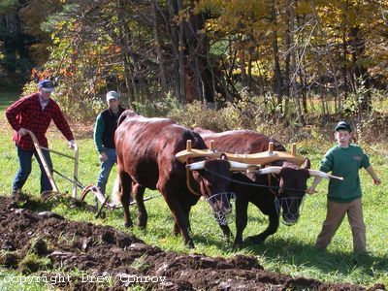

Today, Devons are still sought out for use as oxen. Those qualities so highly prized by the colonists can still be found in today's Devons.

In 1858, William Youatt stated that "the Devon as an aboriginal breed of cattle is a very valuable one, and they seem to have arrived at the highest point of perfection."

Today's breeders strive to maintain these very same qualities in the modern Milking Devon. They believe that the Milking Devon is a rare breed that deserves a good future.

The American Milking Devon
Cattle Association

Bonnie Hall, Registrar
610 East Pond Meadow Road
Westbrook, CT 06498

Questions?
Raymond Clark, Director
1429 Red Village Road
Lyndonville, VT 05851
802-626-8306

www.milkingdevons.org

If you are interested in helping to preserve and promote this breed and would like to own and breed Milking Devon Cattle, please contact:

AMERICAN
MILKING DEVON
CATTLE

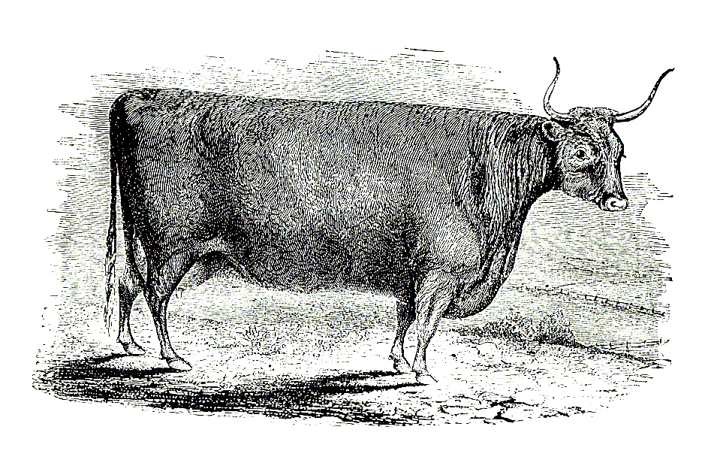

*a triple-purpose breed

*intelligent and willing to work
*outstanding foraging ability

*hardy and long lived

*60% usable carcass

A RARE BREED THAT DESERVES A GOOD FUTURE

